Office of The Most Worshipful Grand Master
April 28, 2022

To: Appointed Right Worshipful Deputy Grand Master Wendell Terry, Elected and Appointed Grand Lodge Officers, Past Grand Lodge Officers, Past Masters, Worshipful Masters, Wardens, and Brethren

PROCLAMATION

Greetings:

Be it known that I, Lynn Lewis, Jr., Most Worshipful Grand Master of The Most Worshipful Prince Hall Grand Lodge of Iowa, F.&A.M. and Jurisdiction, Inc. do hereby proclaim Sunday, June 19, 2022, as The Feast of Saint John the Baptist Day in the State of Iowa.

I do hereby summon all Grand Lodge Officers, Past Grand Masters, Worshipful Masters, Wardens, and Master Masons holding allegiance to this Grand Lodge to assemble and convene in full Masonic dress for service at the Church of your choice, you may also use the Sunday before June 19, 2022, or the Sunday after June 19, 2022.

St. John’s Day is not a Grand Lodge event. This is a Masonic observance to pay reverence to God and honor to the two Saint Johns (Saint John the Baptist and Saint John the Evangelist.) A day that all Masons by duty are to commemorate annually.

This proclamation is to be read at all Masonic meetings before June 19, 2022.

In testimony where of I have set my hand and seal of This Grand Lodge to be affixed this 28th day of April A.D. 2022 A.L. 6022
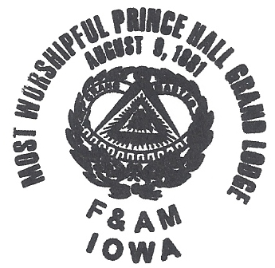

Lynn Lewis, Jr.
Most Worshipful Grand Master

